Step 1: Complete your 2018 Medicare Certification

Step 2: Access initial order through KMSI link at end of your 2018 Certification. (If you close the certificaiton window prior to placing your initial order, wait 24 hours and then access the order site through the included link below.) https://printandfulfillment.adp.com/HumanaDelegatedAgents/Forms/UniversalLogin.aspx
Step 3: Select User Type (Agent or Agency)
Step 4: Enter your San (Humana Agent Number) and Last name
Step 5: Select your type of Order (Initial 2018 Order only available after certification is completed, Reorders are available starting 9/15/17)

Step 6: Follow the Prompts to select your material orders
- Plan year
- Shipping Address
- State & County Selection
- Make Enrollment Book & Individual item selections
Step 7: Review and confirm your order. Select Submit button at bottom of screen to finalize and place the order.
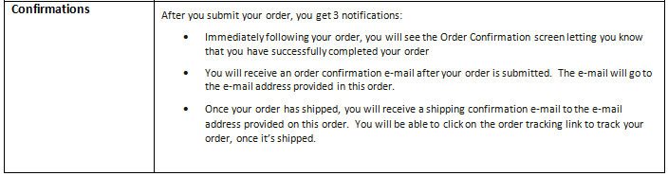
Important Ordering Information

- Initial orders placed before 8/25 will be delivered by 9/30

- 2018 Reorders are available starting 9/15 -Online ordering is the preferred method – however agents can also call Agent Service Unit at 800.309.3163 after 9/15 for reorder assistance.

- Reorders can be placed every 3 days and have a quantity max of 50 – this is a frequency and quantity increase from 2017!

- If you do not place your initial order immediately following your online certification, you can use the order link to place your order after 24 hours. Material order link for agents

New for 2018

Bound Enrollment Book - size 9 ½ x 11 ½ - Includes Benefits at a glance, Benefit Summary, Plan Rating, OTC Benefit Form, PHI Consent Form, Scope of Appointment, Receipt and the Application.

Drug Guides – Will receive 1 formulary for every 5 plan enrollment books ordered. (Per CMS, drug guides are only required to be handed out at the point of sale if a member requests one. A drug guide is automatically sent with members post-enrollment materials.)

Over the Counter (OTC) Benefit – Monthly and quarterly plans will be combined on one form.

Application – Included in each enrollment book and member copy has been removed. Receipt form has been added as client leave behind for each enrollment.

Helpful Videos and Links (Press Ctrl and left click to follow links or copy and paste address into browser)

Material Catalog video
https://vimeo.com/224971931

How to order
http://teams.humana.com/sites/itls/itu/video/Player.html?vl=vod&vn=_definst_/humana/MaterialsOrdering2018.mp4

Material order link for agents
https://printandfulfillment.adp.com/HumanaDelegatedAgents/Forms/UniversalLogin.aspx

